CS375 LAB 5
Multiplexers and VHDL
Use the Altera Quartus software to implement the following:
- Create a block diagram for a 4x1 multiplexer, as shown below (from page 319 of your textbook). Create a symbol for this multiplexer.

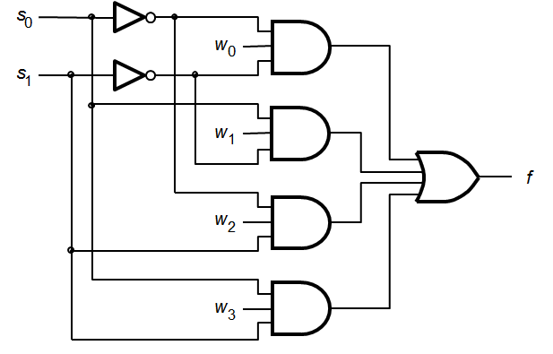

- Use five instances of your 4x1 multiplexer to implement a 16x1 multiplexer.
- Use the 16x1 multiplexer to implement the function ∑m(0,3,6,8,12,13,14).
- Use Shannon’s Expansion Theorem (section 6.1.2 in your text) to implement the same function you implemented in (3) using a 2x1 multiplexer and some additional logic.
- Write a VHDL implementation of a HEX-to-7-segment decoder (code converter). Use the included sample VHDL (from page 348 of your textbook) as a guide. Your design should produce the digits (1-9, A, b, c, d, E, and F). Remember that the 7-segment display is active low.
Demonstrate your working designs on the Altera FPGA Starter Board. Use switches Sw3 through Sw0 to drive the HEX-to-7-segment decoder (Sw3 is the most significant bit). Use switches Sw9 to Sw6 to provide input to the multiplexer you implemented in parts 3 and 4(SW9 is MSB). The output from the multiplexers should appear on LED0 and LED1.
Store your design files on the shared google drive in your lab5 folder.

LIBRARY ieee ;
USE ieee.std_logic_1164.all ;
ENTITY dec2to4 IS
PORT ( w : IN STD_LOGIC_VECTOR(1 DOWNTO 0) ;
En : IN STD_LOGIC ;
y : OUT STD_LOGIC_VECTOR(0 TO 3) ) ;
END dec2to4 ;
ARCHITECTURE Behavior OF dec2to4 IS
SIGNAL Enw : STD_LOGIC_VECTOR(2 DOWNTO 0) ;
BEGIN
Enw <= En & w ;
WITH Enw SELECT
y <= "1000" WHEN "100",
"0100" WHEN "101",
"0010" WHEN "110",
"0001" WHEN "111",
"0000" WHEN OTHERS ;
END Behavior ;

