CS345 Project #3 WPF Calculator
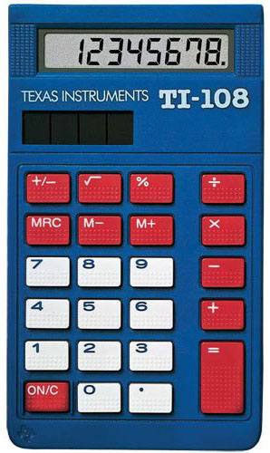
In this project you will produce an emulator for the TI-108 electronic calculator. You do not need to provide all the functions, however you should provide the following:
- Ability to enter a number using the buttons
- Ability to add two numbers using the buttons (use Decimal data types)
- Ability to clear the display
The calculator should look and work like the real thing, but in most cases, approximations are fine. Most of the work will be in writing the XAML code that generates the image of the calculator. The XAML should be written by hand and must be implemented using the following basic structure. Allow the calculator to be reasonably resized without destroying the layout. Default size should be (348x600).
Calculator Colors
Item | Red | Green | Blue
Body | 13 | 82 | 151
Red Button | 209 | 49 | 59
White Button | 240 | 242 | 241
Solar Panel | 25 | 33 | 22
LCD | 183 | 185 | 184
Display Digits | 28 | 29 | 24

<!-- Grid for entire calculator -->
<Grid>
<!-- Grid for LCD display and TI Logo -->
<Grid>
</Grid>
<!-- Grid for Button Area -->
<Grid>
</Grid>
</Grid>
